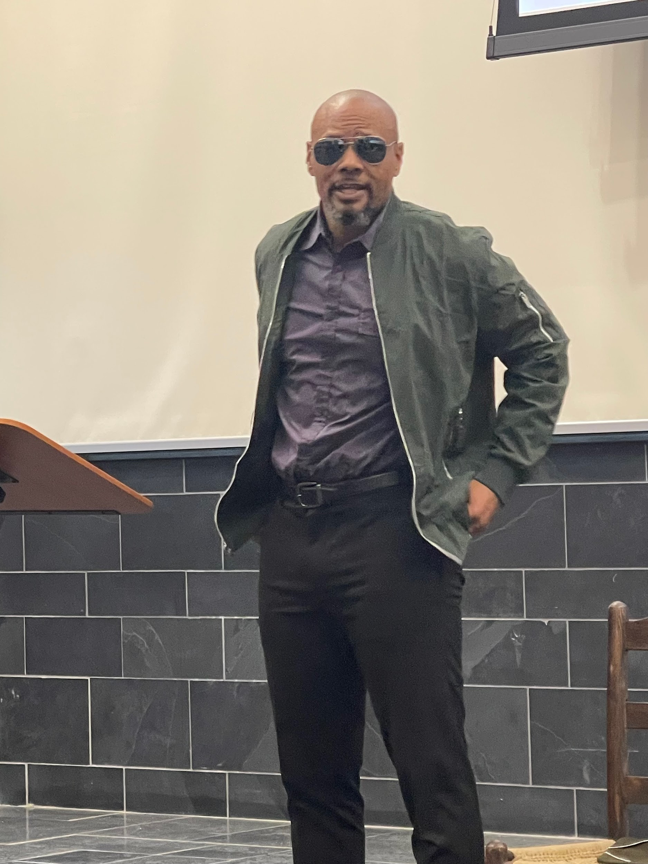
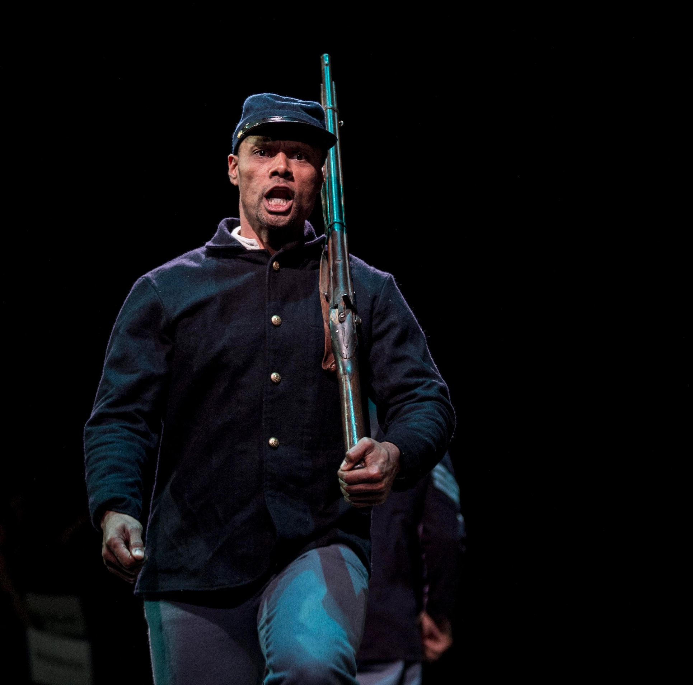
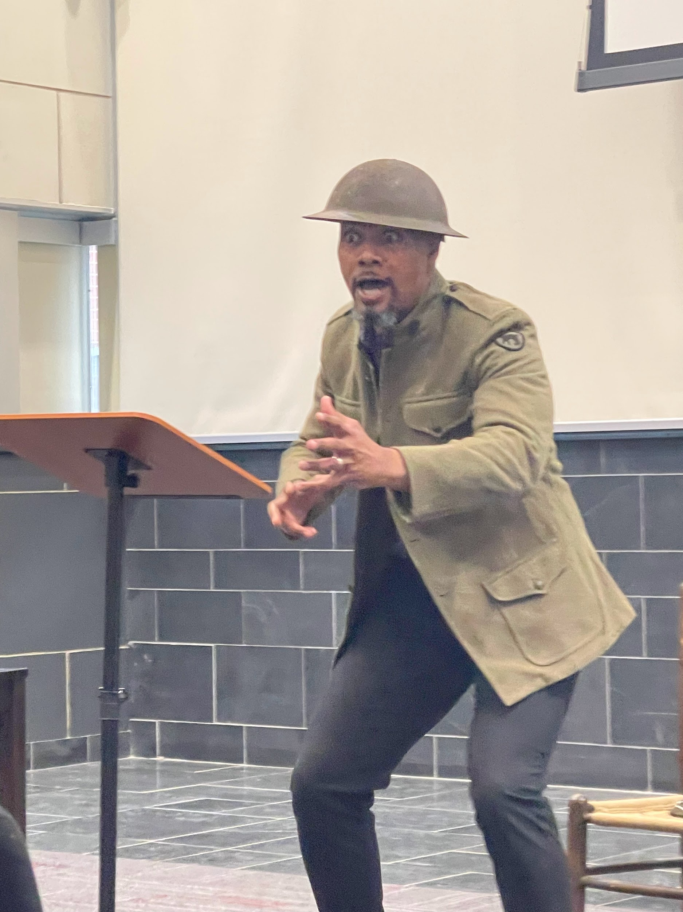
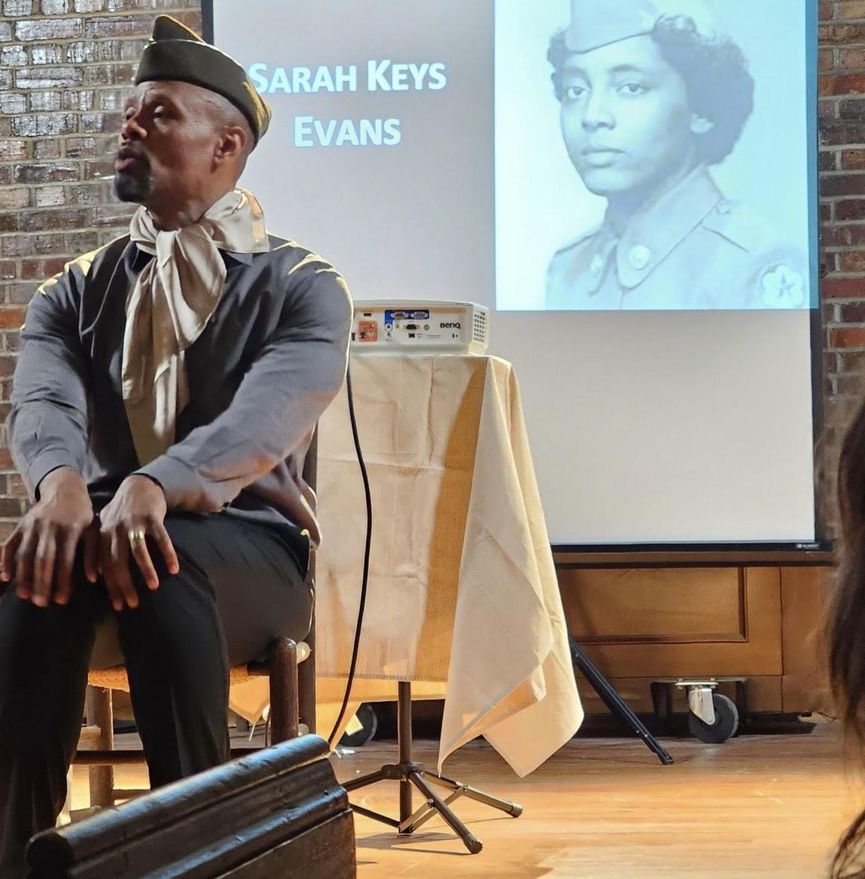
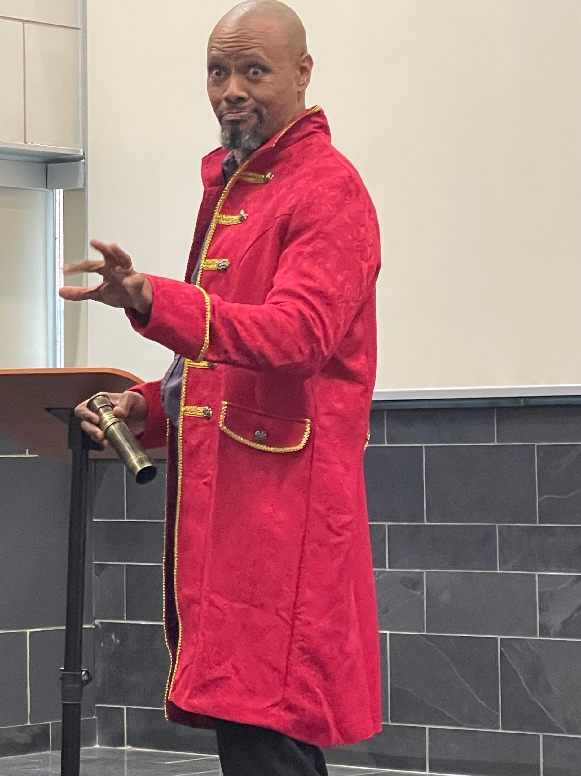
Performance Overview
The Ongoing Fight for Freedom: Stories of NC Black Veterans is a one-man presentation & performance elevating Black freedom fighters and veterans with North Carolina connections – known & unknown, on and off the traditional battlefield – who have engaged in over 400 years of a struggle for freedom, liberty, and equality. Their sacrifices, resistance, and resilience have contributed to American democracy, even as they were denied the full rights of citizens. Through listening to their stories in this production, we can gain a deeper understanding of our nation’s founding ideals, and harness the hope to continue the work, together, of making those ideals a reality for all.
The show was written and is performed by Dr. Sonny Kelly, founder of Legacy Heirs Productions. The play’s development was commissioned & funded by the NC Department of Natural & Cultural Resources’ America 250 NC initiative & produced by Carolina K-12 at UNC-Chapel Hill.
The show is approximately 70-minutes long. It is a small-scale, highly-flexible production, and can thus be adapted to work in any space (from traditional theatres to large conference rooms.)
For additional details about The Ongoing Fight for Freedom & accompanying teaching materials, visit: https://humanities.unc.edu/ncblackveterans/

What “The Ongoing Fight for Freedom” Offers Audiences
- A performance portraying twenty-five Black freedom fighters and veterans with North Carolina connections, spanning four centuries of history, who have engaged in an ongoing fight for freedom, liberty and equality, and contributed to American democracy across time.
- Depth of inquiry, that links un(der)told history, personal narratives, and performance ethnography with our contemporary questions regarding freedom, race, identity, and patriotism in the U.S.
- Profound emotional and physical resonance as a live performance piece that integrates vibrant storytelling and character acting for an engaging and inspirational audience experience.
- Reverent exploration of U.S. history that elevates themes of sacrifice, resistance, and resilience, in regards to Black veterans.
Run Time
The performance runs an average of 70 minutes. It can be adjusted according to needs. The artist is also available for a facilitated Q & A, discussion, and/or panel for 30-45 minutes after the performance.
Content
While no violence or graphic images are included in this presentation, it does include archival images, sounds & video depicting and referencing scenes of battle, war, the Jim Crow era, and racism. Suicide is briefly mentioned.
The presentation is based on historical research, including actual events and people who have contributed to North Carolina throughout the last four centuries. Artistic liberties have been taken in how figures are presented. While some dialogue is taken directly from oral histories or interview sources, the majority of dialogue is interpreted for dramatic intent.
This performance is intended for general public audiences of adults (16+). However, mature children aged 11 and older, who are accompanied by a guardian and are capable of maintaining a seat and focus through a 70-minute production, may also find the experience enriching. Parental discretion is advised.
Private performances for K-12 schools can be tailored to suit grades 4th – 12th.
Technical Requirements
- Performance space that is a minimum of 10 ft. x 6ft. (Ideally, performance space will be slightly elevated for maximum visual quality, while still maintaining an intimate setting that allows the performer easy access to the audience. Proscenium theatres, conference spaces, and other set ups can also be accommodated by speaking with Legacy Heirs Productions.)
- 1 large projector screen, ideally located at least 6ft above center stage; or at the back of the stage (if rear-projected)*
- 1 projector that can project a PowerPoint slideshow with sound*
- Audio system that allows for quality sound throughout the performance (all sound files are embedded in the PowerPoint)*
  - These items can also be provided by Legacy Heirs Productions, LLC for an additional fee.

Crediting Requirements
- The hosting organization agrees to include the following credits in any introduction to the performance provided:
  - This show was written and is performed by Dr. Sonny Kelly, founder of Legacy Heirs Productions. The play’s development was commissioned & funded by the NC Department of Natural & Cultural Resources’ America 250 NC initiative & produced by Carolina K-12 at UNC-Chapel Hill.

- The hosting organization agrees to end any introduction with the following lines to que the start of the performance:

  - From the Revolutionary War to modern day military operations, Black North Carolinians have fought for freedom, both on and off the traditional battlefield. They have defended this nation with valor and vigor, and have cultivated a rich legacy of courage, compassion, and community building that has too often gone unrecognized. This performance sheds light on just a few of the millions of stories of the Black freedom fighters, resistors, soldiers, sailors, airmen, and marines who hail from the Old North State. Dr. Sonny Kelly, an Air Force veteran himself, will shine a light into our shared history by telling their stories, and encouraging each of us to contemplate the ongoing fight for freedom that impacts us all.

- When possible, the hosting organization will provide copies of the presentation’s program (sample program available here). The program will be updated to include appropriate hosts, funders, location, logos, etc.
Hospitality
The hosting organization is asked to provide:
- A private space for the performer to change and warm up before the start of the show.
- Bottled water (2 bottles to be placed within the performance space, as well as water available to the performer before the show.)
Cost
- $5,000 + travel and lodging costs for one full performance, followed by an optional additional hour of Discussion and Q & A.
- $2,500 + travel and lodging costs for excerpts of the performance and the facilitation of interactive community discussions and workshops for up to two hours. ($500 per additional hour)
- $1,500 for virtual engagement with excerpts of the performance and discussion for up to two hours.
- If you are a K-12 school or non-profit organization who is seeking alternative pricing or funding options, contact us to discuss your needs. Prices for additional performances in the same area during the same visit are negotiable.
About Dr. Sonny Kelly

Dr. Sonny Kelly is a U.S. Air Force veteran who is a scholar, performer, story teller, motivator, speaker, teacher, trainer, and founder of Legacy Heirs Productions, Inc. He has acte d professionally on stage and television for over 30 years. Dr. Kelly earned his PhD in Communication at UNC Chapel Hill. He is also a graduate of Stanford University and St. Mary’s University, San Antonio, TX.
Dr. Kelly is an award-winning college communications instructor and currently teaches courses in Public Speaking and Intercultural/Interpersonal Communication at Fayetteville Technical Community College. His research and interests are focused on seeking performance centered practices to name, address and mediate the issues that divide Americans.
Dr. Kelly's work mobilizes theater, storytelling, performance-centered pedagogy, ethnography, and participatory action research to build awareness, understanding, hope, unity, accountability, equity, and inclusion. His passion for empowering others is unmistakable. He is currently performing his original one-man shows and performative lectures:
- The Talk
- The Ongoing Fight for Freedom
- Indivisible
- HAUNTED
Each of these shows call audiences in to grapple with diffusive issues, with empathy and understanding, in order to transcend division.
Learn more at www.legacyheirsproductions.com.

Clients & References

Legacy Heirs Productions Inc has provided speakers, trainers, and performers who have conducted performances, lectures, and workshops for hundreds of satisfied clients including:

- GlaxoSmithKline  - Sentara Health  - RTI  - Assc. of Community Health Workers  - Assc. Maternal & Child Health Programs | - UNC-Chapel Hill  - Duke University  - NCCU  - UNC Greensboro  - Fayetteville State  - Syracuse University  - Georgia Tech  - St. Andrews University | - NC Community Colleges (Carteret, Durham Tech, Fayetteville Tech, Sandhills)  - Carolina K-12  - K-12 Schools Nationwide | - Levin Jewish Community Center  - Cumberland County Arts Council  - The USO  - Junior League  - HMA Community Strategies

- Stephen Valentine, Director of Veterans Law Clinic, North Carolina Central University
Phone (919)530-6946; svalent4@nccu.edu

- Christie Hinson Norris, Director, Carolina K-12 at UNC-Chapel Hill
Phone: (919)843-9387; cnorris@unc.edu

- Joseph Megel, Professor, UNC Chapel Hill Communication Department
Phone: (919)843-7067; E-mail: megel@email.unc.edu

- Dr. Lloyd Kramer, Director of Carolina Public Humanities
Phone: (919) 962-5553; E-mail: lkramer@email.unc.edu

Booking

Presentations are modular and highly flexible, and can be produced on traditional stages, as well as in smaller, non-stage venues. For additional information or to inquire about a performance, contact us at legacyheirsproductions@gmail.com; or visit http://www.legacyheirsproductions.com and select “Contact Us.”

